Robin’s Nest Daily Schedule
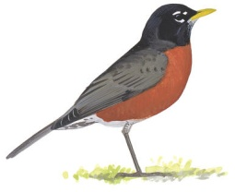
9:00-9:15 Arrival and Table Activities
9:15-9:30 Show and Tell
9:30-10:00 Tuesday and Wednesday-Music with Mr. Keefe
10:00-10:30 Circle Time—Calendar, Weather, Story, Poetry, Theme and Alphabet activities
10:30-10:50 Art Project/Follow-up activity
10:55-11:05 Snack
11:05-11:30 Centers-Art, blocks, play-doh, painting, etc..
11:30-11:35 Clean up and pack up
11:40-12:00 Outdoor Play-weather permitting or large group activity
12:00-12:05 Dismissal

